ASSIGNMENT 1 CSA0984 JAVA PROGRAMING

NAME:VIRINDA SINGH.V

REG NO: 192371012.

DEPARTMENT :BTECH CSE BIOSCIENCE

1. Write a program to check the entered user name is valid or not. Get both the inputs from the user.

Sample Input:

Enter the user name: Saveetha@789

Reenter the user name: Saveetha@123

Sample Output:

User name is InvaliD

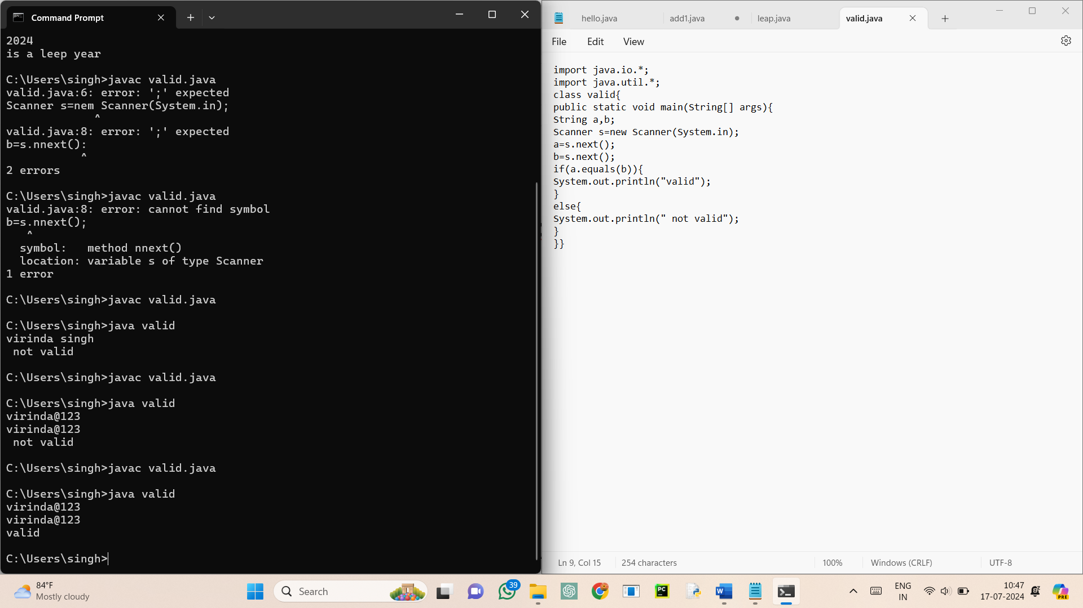

2. Write a program to find whether the person is eligible for vote or not. And if that particular person is not eligible, then print how many years are left to be eligible.

Sample Input:

Enter your age:

7

Sample output:

You are allowed to vote after 11 years

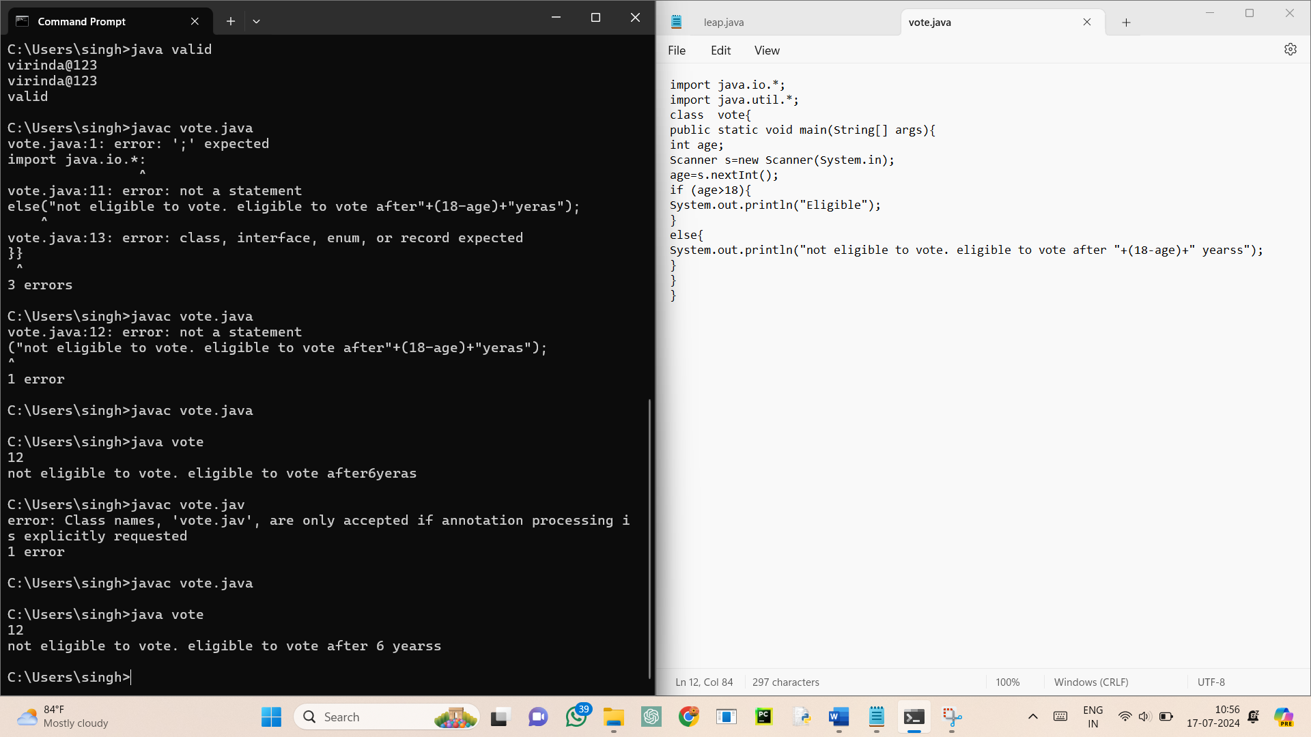

3. Write a program using function to calculate the simple interest. Suppose the customer is a senior citizen. He is being offered 12 percent rate of interest; for all other customers, the ROI is 10 percent.

Sample Input:

Enter the principal amount: 200000

Enter the no of years: 3

Is customer senior citizen (y/n): n

Sample Output:

Interest: 60000

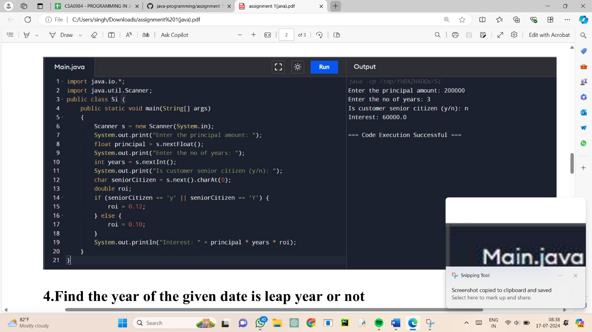

4.Find the year of the given date is leap year or not

Sample Input:

Enter Date: 04/11/1947

Sample Output:

Given year is Non Leap Year

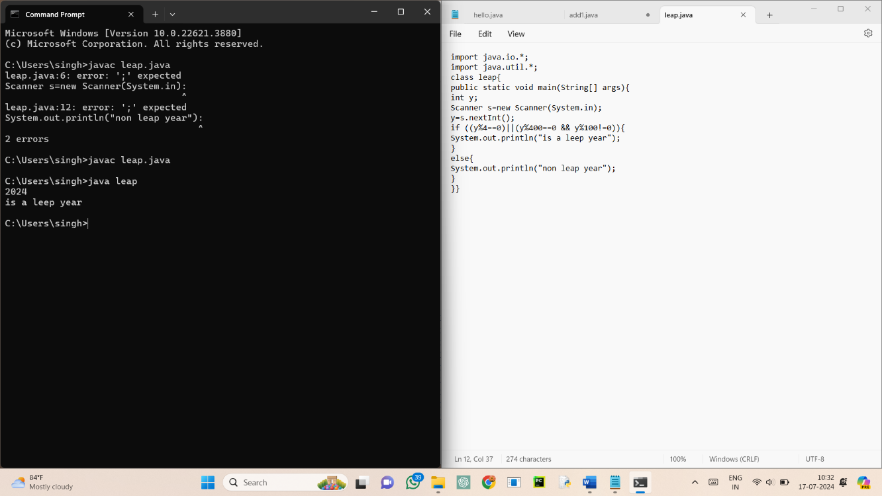

5. Write a program to find the square, cube of the given decimal number

Sample Input:

Given Number: 0.6

Sample Output:

Square Number: 0.36

Cube Number:0.216

